Yuusha Party no Kawaii Ko ga ita no de, Kokuhaku Shite Mita - Volume 1 Chapter 7 (part 1)

友人と依頼に行ってみた
I tried giving a friend love advice.

Translation by Solistia
Proofing/Editing by Hobo, MuscleSpark, Flyingjam, Sumguy, Creed, Frost, Dair, Blesserz, and Friasco

It's been a few days since Cecilia recovered from being sick.
Today I came to the guild to work, but...

"He~ey, guess wha~at, lately the little woman has been in a su~uper good mood~"

"I didn't know that..."

How did I get roped into listening to Clayman gush about his wife?
His eyes that were always like a dead fish’s are sparkling today.
This usually taciturn guy has completely turned into a giggling schoolgirl. Honestly, it's a pain in the ass..

All the other employees and adventurers I see are avoiding looking at us.
Seems he's been like this all day.
The employees are sighing deeply, and the adventurers are keeping their eyes glued to the table.
Looks like I’m not the only victim here.

...Come to think of it, this guy is married? Congrats man. Just what kind of lady would fall for this sorry sod?
I can't imagine it working out if she wasn't completely complacent.

"I never realized what a great place this was to work. Everyone has been su~uper nice today."

"Uh-huh."

She must be a great wife to make him that happy. If I got married to Cecilia and everyday was full of bliss… Ah, stop stop!
I think I'd end up with the same girly smile in his position.

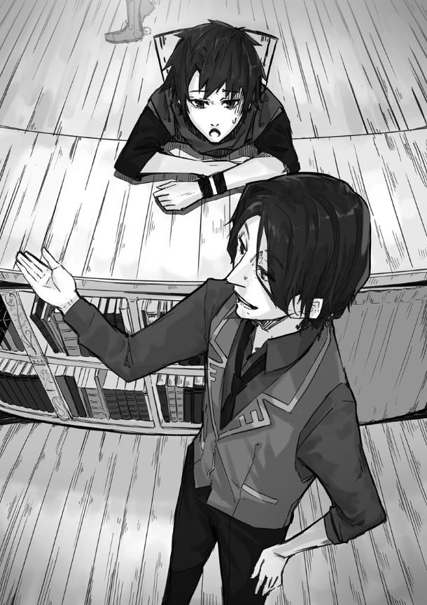
So I had to listen to him gush about his wife for a long while.
From the reactions I could see of those still in the Guild hall, they'd all heard the same story.

Just when I'd had about enough of this nonsense, there was a commotion at the guild entrance.
I could hear cheers of joy from the previously sullen employees and adventurers who had been face-planted on the tables.

"What's up? It's pretty noisy."

Clayman leaned out over the reception desk to check out what was going on at the guild entrance.
I'm getting a sense of déjà vu here.
Could it be… Cecilia?!
With my hopes high, I turn around and see...

“......”

...Raven standing there.
He avoids people with hand and body gestures and heads in my direction.
Coming towards me, he jerked his thumb towards the guild entrance.
It looks like he has something to tell me, but he doesn't want to talk with other people around.
I totally get it.

"Clayman, I want to take a quest with Raven, are there any good ones available?"

He probably wanted to go questing with me.
We finally became friends, but never got to hang out together since he spent his time training.

Raven tugged on my sleeve.
You wanna get out of here that quickly, huh?
I guess the guild is making a lot of noise.
Most of it is jeering towards me though.
It's mainly coming from the women, and even the guild employees.

"Oooh, how 'bout this one? There's a quest to defeat a rampaging rock dragon at the foot of Haggers Mountain. If you take a carriage together, you can probably make it back before the day's over."

It's a B-rank mission, and it would just be Raven from the Hero Party and me who just recently become B-rank, but with me having my Cheat we should be fine. ...We could probably even take a higher ranking mission and still be fine.

Accepting the quest, Raven and I head to Haggers Mountain.

"Eh...you didn't want to do a quest?"

It would take 2 hours by carriage to get to Haggers Mountain from Minerva, so we were looking for a carriage headed in that direction.
There were a lot of people around, so we were conversing quietly.

"...I wanted to go out shopping with you. Maybe grab a bite to eat..."

Apparently Raven just wanted to hang out around town.
I mistook it as him wanting to hunt out of town.
Speaking of which, our equipment might be a bit too light for this quest.

"Sorry for the misunderstanding."

I lower my head in a sincere apology. Raven worked as a knight in the castle, so this was probably a rare day off.

"....No, it's okay. It's just the first outing I've ever had with a friend."

Looks like all is forgiven.
I'm glad Raven has such a big heart.

"I got it, let's finish up the quest real quick, then hang out afterwards. If we give it our all, we should make it back by sundown."

"....I see. Let's do that."

Still, there are things we gotta do before then.
Today, Raven was out in casual clothes, not disguising himself at all.
How reckless can you be?
I don't want to go through another huge fiasco, so I should warn him.

"But before we hang out, there is something I absolutely must tell you, okay?"

Not understanding, Raven tilted his head.

"As a member of the Hero party, if you just walk casually around in the city, you're gonna cause a commotion. Didn’t you hear about when the whole Hero Party, aside from you, were caught in the Accessory Shop and it turned into a huge mess just recently?"

I never want to go through that again.
It wiped me out and caused a lot of trouble for the shop.

"....I heard about it. I was wondering what Yuuga and the others were up to. I never would’ve thought a riot would start with Mikana and Cecilia there..."
Raven has no room to talk.
He wanted to go out on the town without a thought about his fame.
He should know the fangirls of the Hero Party would immediately intercept our little outing.

"I'll lend you the disguise I have. Once you're all set, we can hang out. Well, I say disguise, but it's just hiding your face..."

I should get something to commemorate my first date with Cecilia.
I wasn't able to buy the accessory for her that day, and hadn't had a chance to buy it afterwards.
Exiting the carriage, we head for Haggers Mountain.
If we hurry there, we can cover the distance in a dozen or so minutes.
We travel to the mountain in silence to save our stamina.

The path to Haggers Mountain was steep, and we were attacked by monsters, a Lizardman and a Roc, on the way.
The Lizardman, as the name might imply, was a reptilian humanoid that used a sword and shield.
The Roc was a huge, hawk-like monster.

With Raven's sword and my magic, the enemies weren't a big deal at all.
Even so, we didn't know when and where enemies would come from. We both stayed on our guard and continued in silence, however...

"....Youki, after we're done with this quest, I need your advice on something."

Raven suddenly opened his mouth.
...Don't drop lines that'll trigger your death flag!
But, if it's Raven I'm sure he'll be fine.

"Sure thing. Let's hurry and kill this thing then."

Just then, something stomped in our direction with a huge thudding sound.
....Wait, is this really the death flag at work?

"Here it comes, get ready!"

Raven drew his sword from its sheath and took up a stance.
As a magic user I didn't have a weapon, so I just stood at the ready.
As we did, our target, the Rock Dragon, appeared.

"Here we go. 《Storm Blow》!"

Storm Blow is an Intermediate level magic that, while small in scale, has the power of a tornado.
Hitting the Rock Dragon with this skill, it shaves off some of the hard rock armor.
And thus, it exposes the skin underneath.

“Yes!”

Raven slashed at the exposed skin.
After being cut, the dragon flew into a rage but Raven carefully dodged, and continued to wound the monster with his sword.
The Rock Dragon was unintelligent, so as long as we remained vigilant we wouldn’t get hit.
Even though it's called a dragon, it wasn't much of an opponent.

We kept at it, and safely slew the dragon. ...Thank goodness, the death flag wasn’t triggered after all.

"Good work. I'm glad we got it over with quickly."

I released my magic, and as Raven sheathed his sword and said,

"...Oh right. Let's leave the Rock Dragon's corpse to the guild staff and just take some proof with us."

The Rock Dragon is huge, there's no way we can deal with the corpse by ourselves, so we just bring back a trophy from it.

“Then let’s hang out when we get back.”

After that, we descended Haggers mountain, boarded the carriage and headed back to Minerva.

After getting back to the guild and reporting on our quest, we head for my room at the Inn.
On the way there was a small fuss, but thanks to my previous experience we were able to escape.

“Here are some glasses and a hat. ...It’s quite late already, so we can't do much except get a bite to eat.”

I handed Raven the disguise I had gotten from Cecilia.

“....Aah, this’ll help a lot.”

He donned the hat, and put on the glasses.
....It kinda suits him.
I guess it's true pretty boys look good, no matter what they wear.
The world is so unfair.
Still, at least he shouldn't be found out.

Having a sword might expose him, so we left it in my room.
We walked for about 10 minutes to the eatery.

“...Come to think of it, didn't you have something you wanted to talk about?”

I asked while eating my dinner.
If I remember right, just before we got ambushed by the Rock Dragon he wanted advice on something.

“...Aah, you’ll hear me out?”

I wonder what it’s about, something to do with his voice?
Did someone say something to him?

“The truth is, I’ve fallen in love with someone.”

Unexpectedly, he wanted some love advice.

--------------------------
Author’s Note: The next chapter will follow Raven-kun.

