Yuusha Party no Kawaii Ko ga ita no de, Kokuhaku Shite Mita - Volume 1 Chapter 5 (part 2)

元部下の願いを叶えてみた
I tried to fulfill the wish of my former underlings.

Translation by Solistia, Proofed by Hobo, MuscleSpark, and Flyingjam

I lightly slapped my three underlings who had turned to stone to bring them back to their senses.
That summary was probably too simple, so I gave them a more in-depth explanation.

"Captain, why are you chasing the skirt of a human girl? Captain's a demon, right? Getting rid of your horns and wings— it's too tragic."

Duke was drowning himself in tears.
Cecilia is the one who invited me out to the world beyond my room.
It's not like I was just a skirt chaser.

“...Repulsive.”

That was uncalled for.
Hey, Hapyneth, don't you look away from me!

"Ahahaha, ahahaha〜 It's no use, I can't stop laughing!"

'Can't stop' my ass! Quit it Sheik, you're being obnoxious!

"Haaa~ Anyway, right now I'm a human Youki, living a human lifestyle. ...I'm not your captain anymore. I came here for a quest. See ya, live long enough to fall in love, guys."

It's sad but I need to draw the line.
For both Cecilia and these guys.

"No way! Captain is our Captain."
"...That's right."
"I think so too~"

What are these guys thinking?

"No, I mean, I'm living as a human now, I'm no longer a demon."

"So that Cleric girl, she's a looker is she?"
"...Beautiful girl type."
"Forget about her looks, those breasts of hers~"

These guys didn't listen to a word I said.
And Sheik. Why do you know about that?

"I'd like to meet her, the human girl Captain fell for."
"...Agreed."
"Me too! Me too!"

What are these guys up to?
While I stood there stunned, those three just carried on with their conversation until they decided on something.

"We have come to a decision; we want to meet the human Captain's in love with."

“Are you retarded?!”

What's with this sudden turn of events?
Before they were acting all cool, now they’re all pumped for a meet-and-greet.

"In the first place, I came here for a quest. I need to kill the cockatrice that's been terrorizing the villagers around here. I don't have time to play around with you lot..."

"Roger that!"
"...Move out."
"And we’re off~"

I was going to stop them, but they thoroughly ignored me and headed out into the forest.
Sometime later, the threesome came back dragging along the corpse of the cockatrice. Those little shits, at least give me a part to play in my own quest!

"Now we can go!"
"...Mission complete."
"Been a while since I last exercised~"

No matter what I say, they're intent on meeting Cecilia.

"...If you're willing to go that far, you must be prepared, right?"

One hurdle we absolutely have to clear is getting them into the imperial city.
It’s up to me to beat some understanding into them.

"Of course!"
"...Acceptable."
"No worries~"

They seem very determined.
It can't be helped if they're that resolved.
Guess I gotta bring them home with me.
I gave them my okay and they rejoiced. A rather intrepid smile appeared on my face.

Two days later...

With the threesome in tow, I returned to the guild to complete my cockatrice quest.

"Captain...I can barely see...do I really have to wear this?"

"If you take it off there'll be a huge commotion. Well, I would eliminate any commotion before it got started with my magic, but you get the point."

Duke was wearing a helmet to keep his head from falling off, and the helmet was strapped to his armor.
This why he just looks like a normal armored knight.

"There are so many amazing things~"

Without his wings, Sheik looks like a normal cute young boy.
His wings are so small they're easily hidden by clothes.
The real problem was...

I could hear the sound of gentle sobbing behind me.

Hapyneth.
She's a harpy so there are feathers all over her arms and legs.

I pondered over how to go about her disguise, and she earned my respect with her earnestness.
The result was...

“...Who will want to marry me now?”

It wasn't so much a full-body waxing as it was a full-body plucking.
...It might have been overkill, but it’s what she wanted.
There were no regrets.
Duke said 'Captain, this is too much!', and even Sheik was all 'I can't even laugh about this...'.
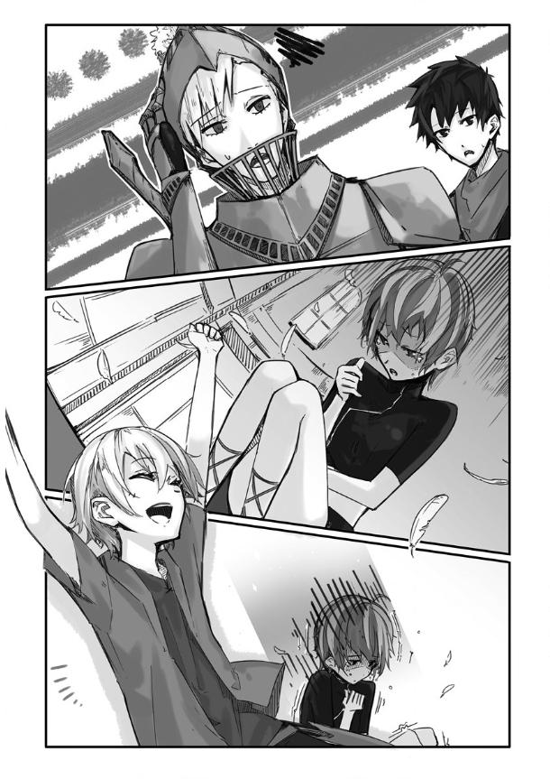

...Even so, she didn't regret it.
As such, thanks to me they were able to pass as humans and accompany me back.
We went to see the lazy receptionist Clayman at his desk.

"Clayman, I've completed the quest to slay the cockatrice. I've already given the corpse to another staff member."

"M'kay, then I'll finish processing it...Yeesh, what a pain in the ass."

Clayman had finally given in. Just recently he stopped directing me to the other receptionists.

"...Hey. 'Those three behind you your friends or somethin'? An armored knight, a brat, and...hey, what's that girly crying for? You do something to her, you scoundrel?"

“Ah, no idea.”

Clayman inclined his head at me as I played dumb. But because it was too troublesome he didn't bother to inquire any further. After he finished, I headed out with my three tagalongs to the Aquarain mansion.

